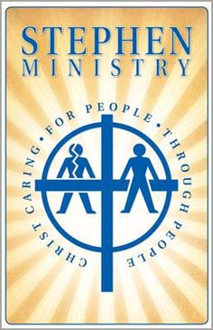

Request for a Stephen Minister

The Stephen Ministry of Bear Creek United Methodist Church is available to individuals who want to request a Stephen Minister. The Stephen Ministry provides one to one Christian care to anyone going through a difficult time.

A request for a Stephen Minister can be made by completing the form below, placing it in a sealed envelope addressed to Stephen Ministry, and submitting it to the church office during regular business hours. The person making the request will be contacted to complete the process for obtaining a Stephen Minister.

---------------------------------------------------------------------------------------------------------------------

Stephen Minister
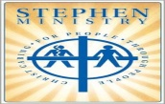
Request Form

Please print.

First Name________________________________ Last Name___________________________

e-mail:________________________________________________________________________

Home Phone ______________________________Mobile/Cell Phone_____________________

Mailing Address:

Street: ________________________________________________________________________

City ____________________________State _____________________Zip code_____________

Check the following statement and sign the form, below.

_____I want to request a Stephen Minister.

Signature______________________________

