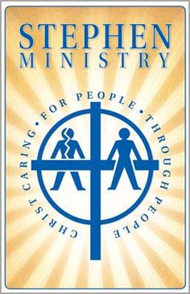

Stephen Ministry Training

Bear Creek UMC is forming a new class for training Stephen Ministers in 2019. A Stephen Minister is a well-trained caregiver who listens, prays, encourages, and offers the love of Christ to people during a difficult time.

Anyone interested in becoming a Stephen Minister or wants to be re-activated as a previously trained Stephen Minister, should complete this form and submit it to the church office in an envelope addressed to Stephen Ministry Training. A Stephen Minister will contact you to provide additional details.

Stephen Minister
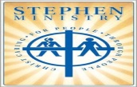
Training Request Form

Please print.

First Name________________________________ Last Name___________________________

e-mail:________________________________________________________________________

Home Phone ______________________________Mobile/Cell Phone_____________________

Mailing Address:

Street: ________________________________________________________________________

City ____________________________State _____________________Zip code_____________

Check one:

_____I want to be trained as a Stephen Minister.
_____I have been previously trained as a Stephen Minister and want to be re-activated.

Signature______________________________

